Optimizing User, Group, and Role Management
With Access Control and Workflows
Prepared For: Project Documentation
Date: 13 February 2026

Executive Summary
This document outlines a structured approach to managing users, groups, roles, access control, and workflow processes within a small project management environment. The objective is to establish clarity in responsibilities, enhance security, and improve accountability throughout the project lifecycle.

1. Problem Statement
In a small project management team consisting of a Project Manager (Alice) and a Team Member (Bob), there is a need to efficiently manage project tasks and ensure accountability throughout the project lifecycle. The existing system lacks clearly defined roles, structured access control, and a standardized workflow, resulting in confusion regarding task ownership, assignment, and progress tracking.

2. System Overview
The proposed solution introduces a Role-Based Access Control (RBAC) model combined with structured workflow management. The system is organized into Users, Groups, Roles, Access Control Lists (ACL), and Workflow Processes to ensure clarity and scalability.

3. User Management
The system includes the following users:
• Alice – Project Manager
• Bob – Team Member
Each user is authenticated and granted permissions based on assigned roles and groups.
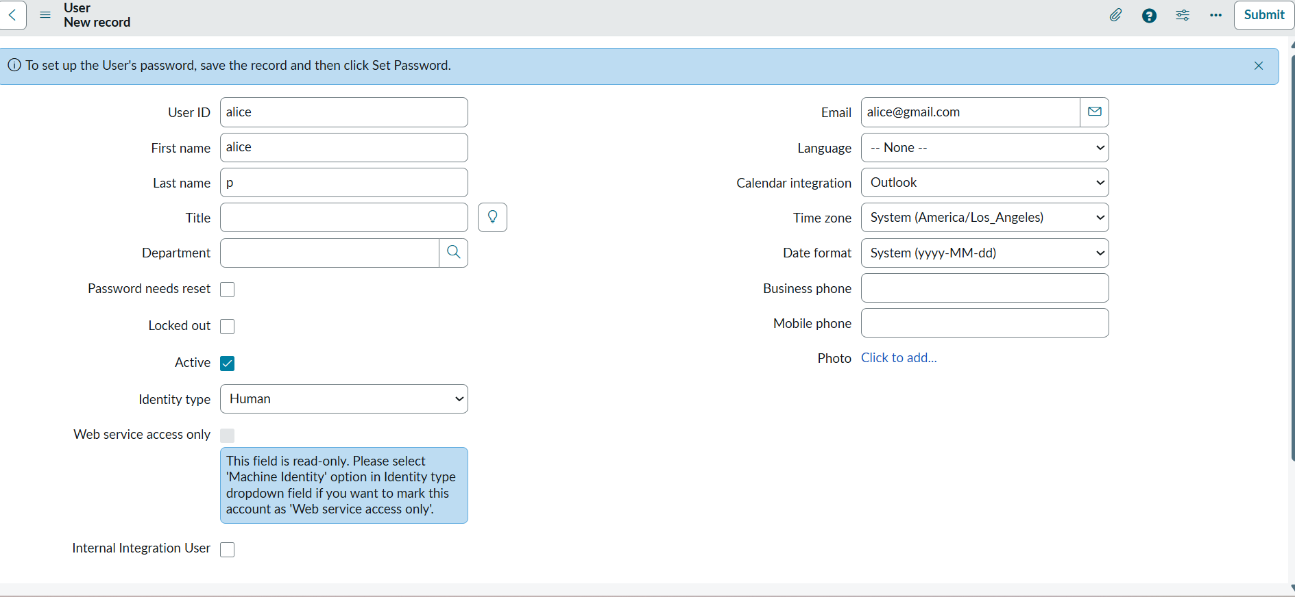

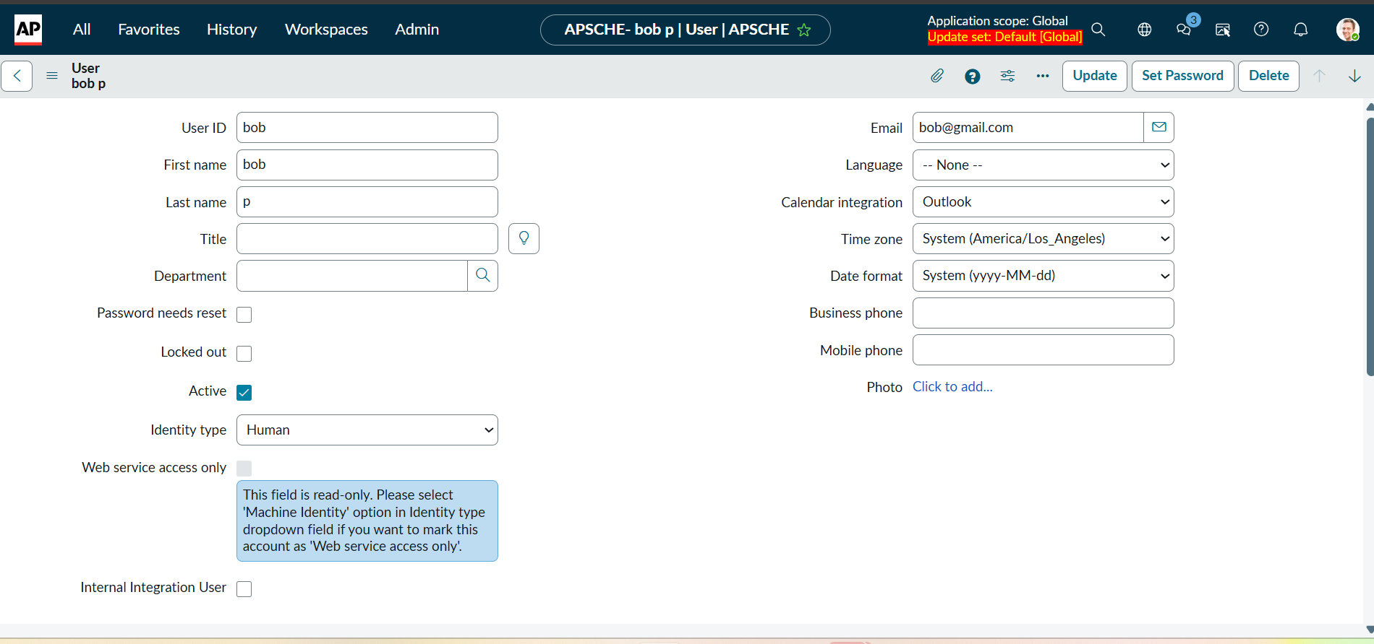

4. Group Management

Groups logically organize users and simplify permission assignment.
Example Groups:
• Project Management Group
• Development Team Group
Group-based permissions improve scalability and reduce administrative overhead.

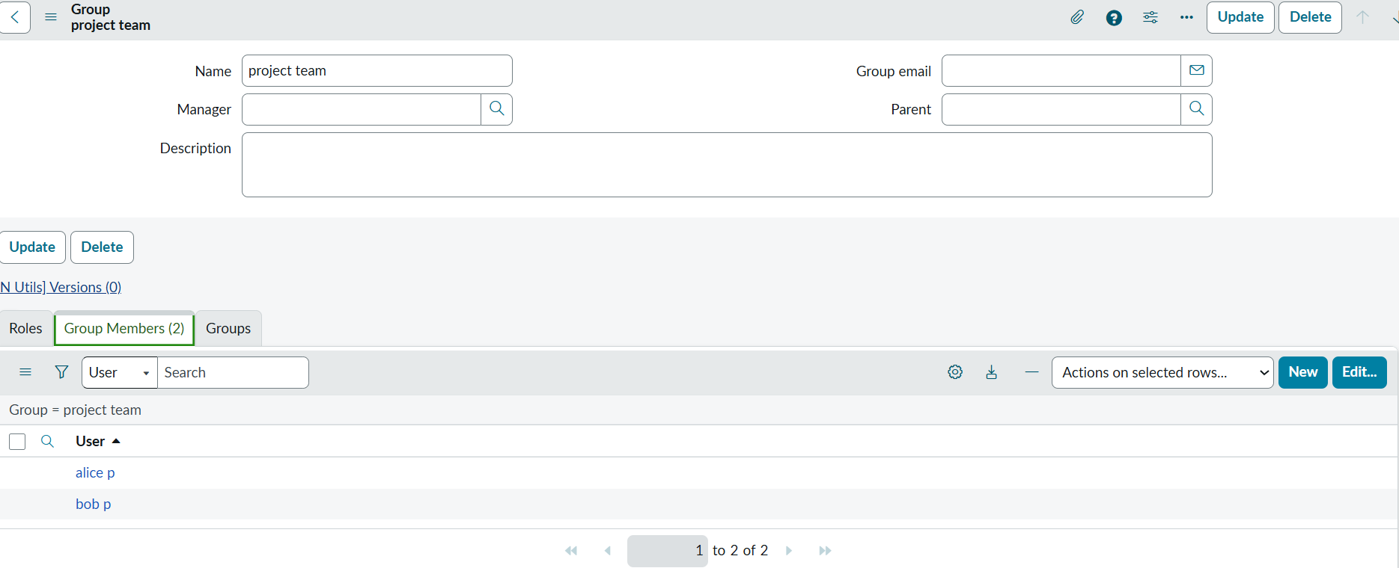

5. Role Management

Roles define system capabilities and responsibilities.
Project Manager Role:
• Create, assign, and delete tasks
• Approve task completion
• Access reports and dashboards
• Manage users and roles
Team Member Role:
• View assigned tasks
• Update task status
• Submit tasks for review
• Add comments or attachments
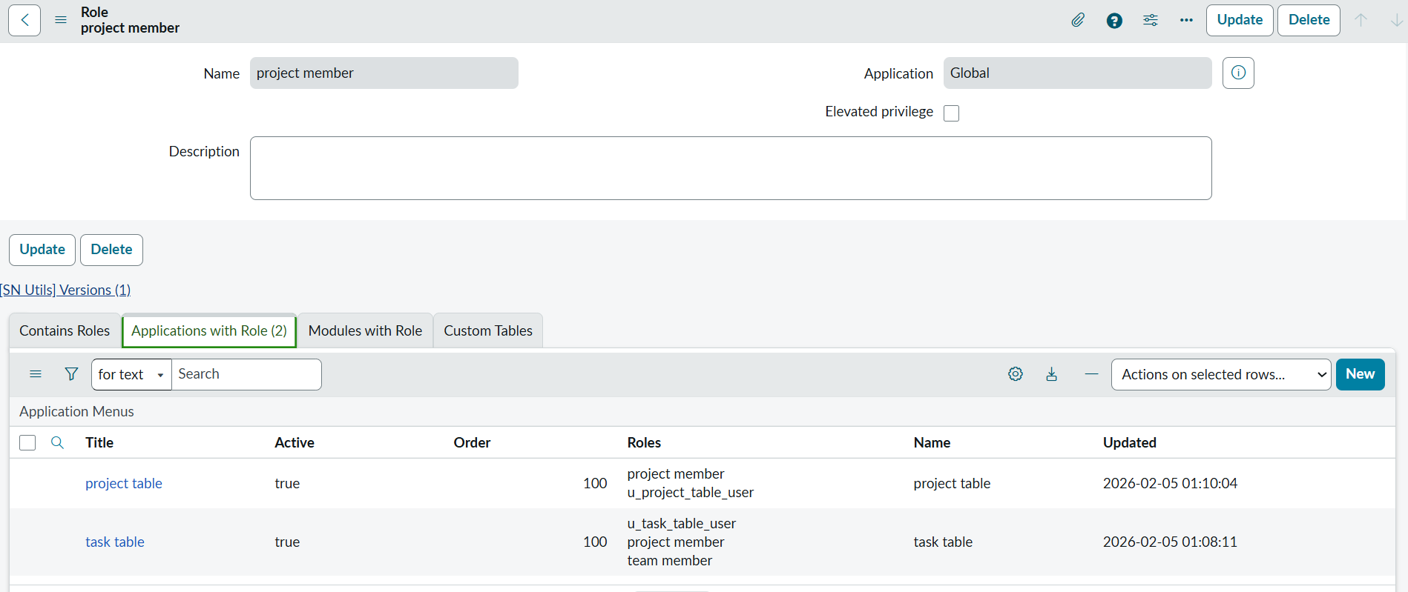

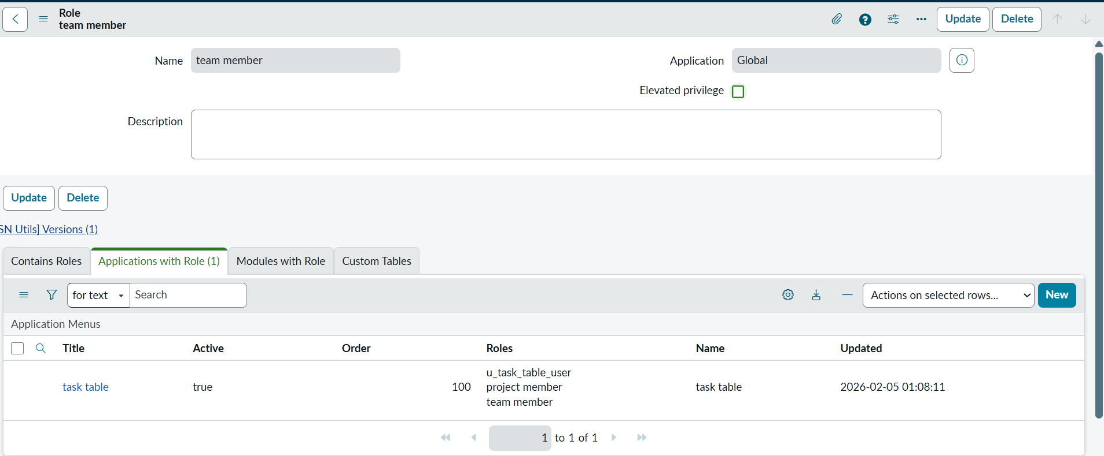

6. Access Control Model (RBAC)
The system implements Role-Based Access Control to ensure users can perform only authorized actions.
Action | Project Manager | Team Member
Create Task | Permitted | Not Permitted
Assign Task | Permitted | Not Permitted
Update Assigned Task | Permitted | Permitted
Delete Task | Permitted | Not Permitted
Approve Task | Permitted | Not Permitted
View Reports | Full Access | Limited Access

7. Assignment Configuration

User-to-Group Mapping:
• Alice → Project Management Group
• Bob → Development Team Group

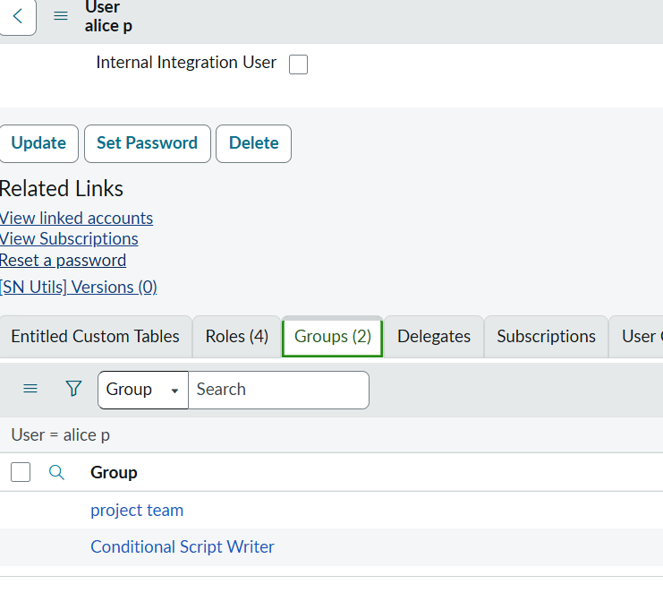
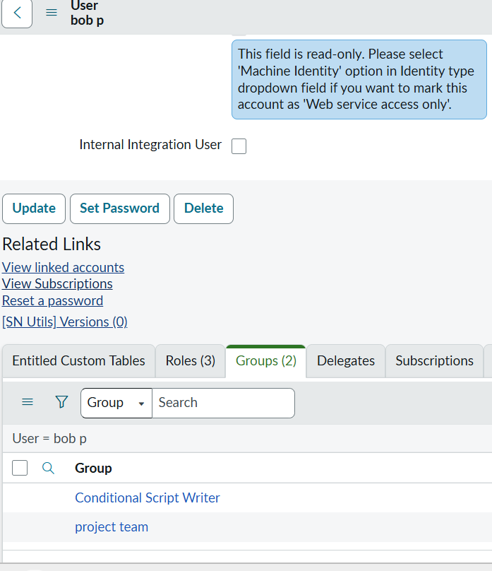

User-to-Role Mapping:
• Alice → Project Manager Role
• Bob → Team Member Role
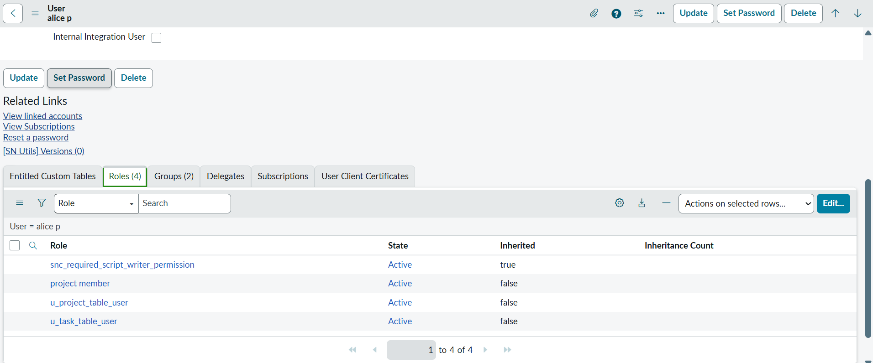
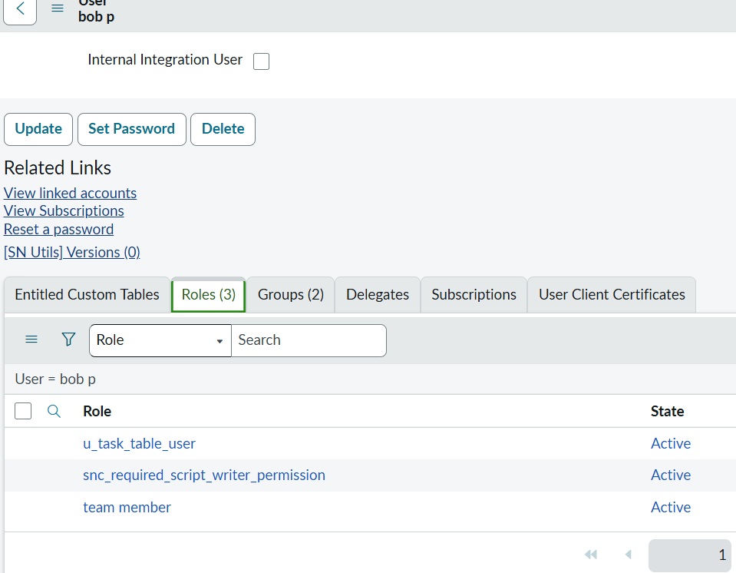
8. Application Access and Access Control List (ACL)
The Access Control List (ACL) validates each user request against predefined role permissions before granting access to system resources. This ensures security, prevents unauthorized operations, and maintains system integrity.

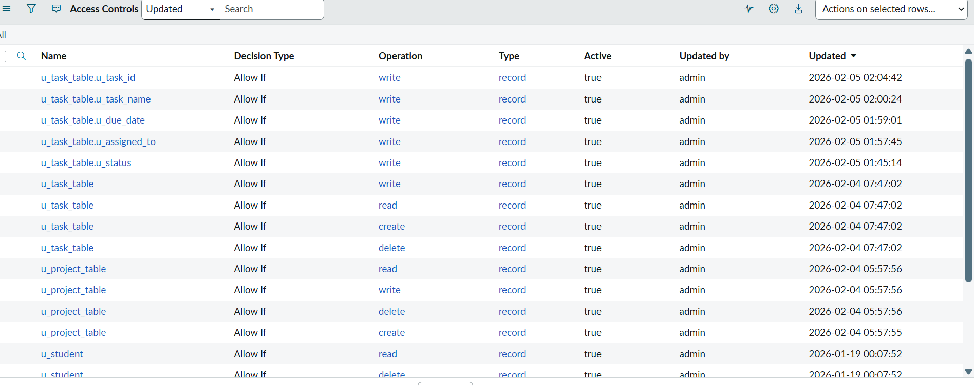

9. Workflow Process
Task Lifecycle Flow:
1. Task Creation by Project Manager
2. Task Assignment to Team Member
3. Task In Progress
4. Task Submission for Review
5. Approval or Rejection
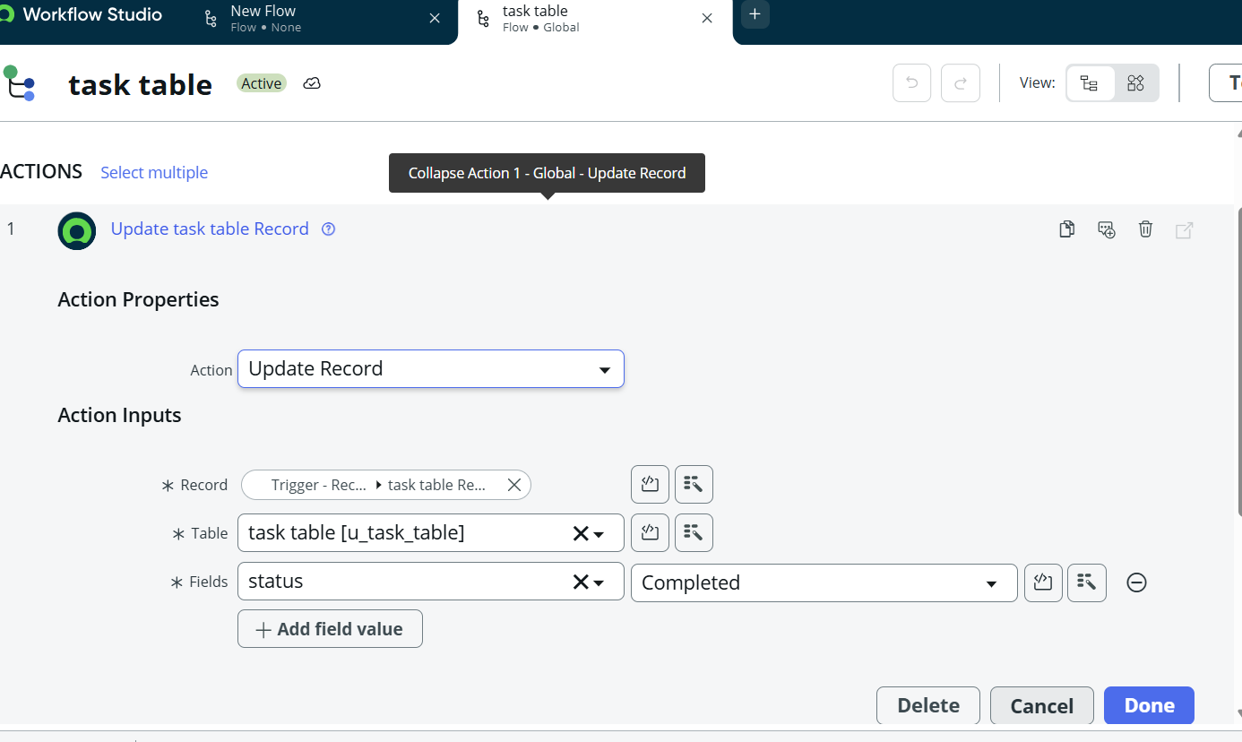
6. Task Closure
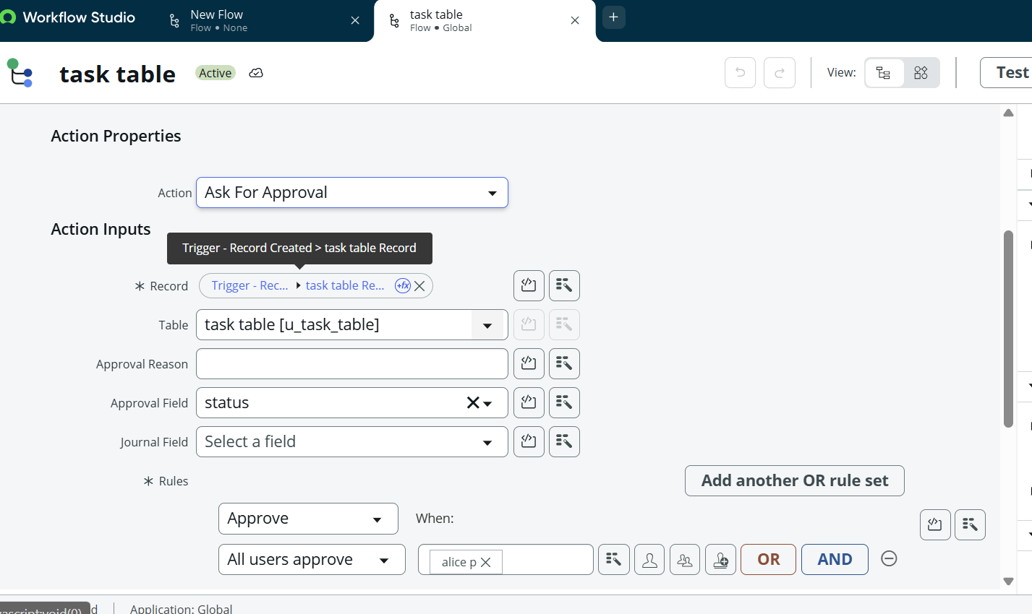

10. Benefits of the Proposed System
• Clear responsibility mapping
• Improved accountability and transparency
• Enhanced security through RBAC
• Scalable group-based permission management
• Structured workflow tracking

11. Conclusion
Implementing structured user, group, and role management combined with access control mechanisms and workflow automation significantly improves project governance. The proposed model eliminates ambiguity, enhances security, and ensures efficient project lifecycle management.

